Pre-Calculus Final Exam Review: CH6 Vectors & Polar Graphs; CH3 Exponential & Logarithmic Functions; CH9(and Sec.1.9) Conics; CH10 Sequences & Series; and CH2 Rational Functions
It is suggested to go back to each chapter and redo the review worksheets provided for those assessments, as well as, complete the following:
- Find the domain of $f\left(x\right)=\frac{2x-5}{x+4}$ in interval notation.

- Find the domain of $f\left(x\right)=\frac{3x}{x^{2}-5x-14}$ in interval notation.

- Find the zeros of $f\left(x\right)=\frac{2x-9}{x^{3}+{2x}^{2}-8x}$

- Find the zeros of $f\left(x\right)=\frac{x^{3}-x^{2}-6x}{{-3x}^{2}-3x+18}$

- Find the horizontal asymptote, if there is one, of each:

- $f\left(x\right)=\frac{15x}{{3x}^{2}+1}$ b) $f\left(x\right)=\frac{15x^{2}}{{3x}^{2}+1}$ c) $f\left(x\right)=\frac{15x^{3}}{{3x}^{2}+1}$

- Convert each to polar coordinates (in radians):
- $(5\sqrt{2}, -5\sqrt{2} )$ b) $(-7, -7)$ c) $\left(0,-3\right)$ d) $(-3\sqrt{3}, -3)$

- Convert each to rectangular coordinates in exact form:
- $(3, \frac{π}{2} )$ b) $(2, \frac{7π}{4})$ c) $\left(4,\frac{5π}{6}\right)$

- Graph each of the following polar equations (include enough points for an accurate graph):
- $r=2+4cosθ$ b) $r=2cos4θ$ c) $r=3sin3θ$ d) $r=2+2sinθ$

- A force of 20 N is pulling an object east and another force of 10 N is pulling the object in the compass direction of 150 degrees. Find the magnitude of the resultant force.

- If a 120 lb box sits on a ramp that makes a 40 degree angle with the horizontal, find:

- The component of the 120 lb force that is parallel to the ramp.
- The component of the 120 lb force that is perpendicular to the ramp.

- Determine the angle between vector $\vec{u}=\left\langle 2, \left.4\right\rangle \right.$and vector $\vec{v}=\left\langle 5, \left.3\right\rangle \right.$. Round to the nearest 10th of a degree.
- Find the vector that has initial point P (-1, 6) and terminal point Q (7, -5).
- Find the magnitude of vector $\vec{u}=\left\langle -1, \left.4\right\rangle \right.$
- Use the dot product to determine whether $\vec{v}=\left\langle 12, \left.-8\right\rangle \right.$and $\vec{u}=\left\langle 2, \left.3\right\rangle \right.$are orthogonal.

- A heavy crate is dragged 50 feet along a level floor. Find the work done if a force of 30 lbs at an angle of 42 degrees is used. Round to the hundredths.

- Solve each. Round to four decimal places, if needed.
- ${10}^{2x}=55$ b) $5^{2x-1}=55$ c) ${4e}^{2x}=6$

- Evaluate each:
- $\log_{\sqrt{2}}1$ b) $\log_{2}(-1)$ c) $\log_{2}\frac{1}{8}$

- Simplify each to a single log:
- $3\log_{b}x-2\log_{b}y+\frac{1}{2}\log_{b}z$ b) $\frac{1}{2}\log_{b}x+3\log_{b}y-2\log_{b}z$

- Simplify:
- $lne^{4x}$ b) $lne^{3ab}$

- Solve each:
- $9^{x}={\left(\frac{1}{27}\right)}^{x+5}$ b) $5^{2x}={125}^{x-1}$

- Solve for x:
- $\log_{5}\left|x\right|=2$ b) $\log_{x}\frac{1}{49}=2$ c) $\log_{3}\frac{1}{81}=x$

- Simplify each:
- $e^{lnx^{2}}$ b) $e^{5lnx}$ c) $e^{3+lnx}$

- Simplify each:
- ${ln 3e}^{7}$ b) ${ln 2e}^{3}$

- Solve for x:
- $\frac{\log_{7}(x+1)}{2}=1$ b) $2\log_{5}\left(x+1\right)-\log_{5}x=1$

- Find the principal needed to give you $500,000 in 20 years with a rate of 12% compounded monthly.

- Evaluate each to 4 decimal places:
- $\log_{3}7$ b) $\log_{5}3.8$

- a) How many terms are in the arithmetic sequence: 178, 170, ……. 2?
- How many terms are there that are multiples of 6 between 1 and 1000.

- State whether the given sequence is arithmetic, geometric, or neither. If arithmetic, give the common difference, if geometric give the common ratio.
- 17, 21, 25, 29, … b) 8, 12, 18, 27, … c) 1, 4, 9, 16, …

- Determine the sum of all the multiples of 5 between 1 and 497.
- Find the sum of the series in terms of x:
$\frac{x^{2}}{3} - \frac{x^{4}}{6} + \frac{x^{6}}{12} -$ …

- What is the sixth term of the sequence defined by: $t_{1}=4; t_{2}=16 and t_{n}=t_{n-1}+t_{n-2}$

- Find the vertex and focus of the parabola: ${(y-2)}^{2}+16\left(x-3\right)=0$

- Find the vertex and focus of the parabola: $x^{2}+8y=0$

- Find the vertex and directrix of the parabola: $x^{2}+2x-4y+17=0$

- Give the standard form of the equation of the parabola with the given characteristics:

Vertex: $(-3, 1)$ focus: $(-1, 1)$

- Find the center and foci of the ellipse: $\frac{{(x+5)}^{2}}{5}+\frac{{(y+9)}^{2}}{9}=1$

- Find the standard form of the equation of the ellipse with vertices $\left(0, ±5\right)$ and eccentricity $e=\frac{4}{5}$

- Find the center and vertices of the hyperbola: $11x^{2}-25y^{2}+22x+250y-889=0$

- Find the center and vertices of the ellipse: $x^{2}+9y^{2}+16x-54y+136=0$

- Find the standard form of the equation of the hyperbola with the given characteristics:

Vertices: $\left(0, -1\right), (10, -1)$ asymptotes: $y=\frac{3}{5}x-4, y=-\frac{3}{5}x+2$

- You should also be able to graph any of the above conics.

Answers:
$1) \left(-∞, -4\right)∪(-4, ∞)$ 2) $\left(-∞, -2\right)∪\left(-2, 7\right)∪( 7, ∞)$ 3) x-int: $\frac{9}{2}$
4) x-int: $0, -2, 3$ 5) a) $y=0$ b) $y=5$ c) none
6) a) $(10, \frac{7π}{4})$ b) $(7\sqrt{2}, \frac{5π}{4}$) c) $(3, \frac{3π}{2})$ d) $(6, \frac{7π}{6})$
7) a) $(0, 3)$ b) $(\sqrt{2}, -\sqrt{2})$ c) $(-2\sqrt{3}, 2)$
8) a) b) c) d)
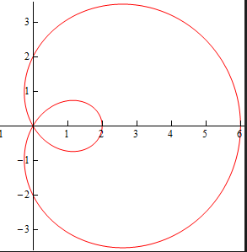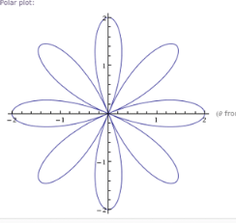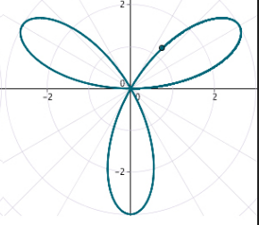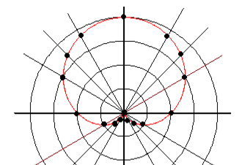

9) 26.5 N 10) a) 77.1 lbs b) 91.9 lbs 11) $32.5°$ 12) $\left\langle 8, \left.-11\right\rangle \right.$ 13)$\sqrt{17}$
14) yes, orthogonal 15) 1114.72 ft-lbs 16) a) $0.8702$ b) $1.7449$ c) $0.2027$
17) a) 0 b) no solution c) $-3$
18) a) $\log_{b}\frac{x^{3}\sqrt{z}}{y^{2}}$ b) $\log_{b}\frac{y^{3}\sqrt{x}}{z^{2}}$
19) a) 4x b) 3ab 20) a) $-3$ b) 3 21) a) $±25$ b) $\frac{1}{7}$ c) $-4$
22) a) $x^{2}$ b) $x^{5}$ c) $e^{3}x$ 23) a) 7 + ln3 b) ln2 + 3 24) a) 48 b) $\frac{3±\sqrt{5}}{2}$
25) $45,902.92 26) a) 1.7712 b) 0.8295 27) a) 23 b) 166
28) a) arithmetic; 4 b) geometric; $\frac{3}{2}$ c) neither 29) 24,750 30) $\frac{2x^{2}}{3x^{2}+6}$ 31) 92
32) vertex: (3, 2) focus: $(-1, 2)$ 33) vertex: (0, 0) focus: $(0, -2)$
34) vertex: $(-1, 4)$ directrix: $y=3$ 35) ${(y-1)}^{2}=8(x+3)$
36) center: $(-5, -9)$ foci: $(-5, -11)$; $(-5, -7)$ 37) $\frac{x^{2}}{9}+\frac{y^{2}}{25}=1$
38) center: $(-1, 5)$ vertices: $\left(-6, 5\right); (4, 5)$
39) center: $(-8, 3)$ vertices: $\left(-11, 3\right); (-5, 3)$ 40) $\frac{{(x-5)}^{2}}{25}-\frac{({y+1)}^{2}}{9}=1$

